Pneumatics Design Methodology Report
Design Rule-
Compressed Gas Cylinders and Lines -
Any system on the vehicle that uses a compressed gas as an actuating medium must comply with the following requirements:

a. Working Gas-The working gas must be nonflammable, e.g. air, nitrogen, carbon dioxide.

b. Cylinder Certification- The gas cylinder/tank must be of proprietary manufacture, designed and built for the pressure being used, certified by an accredited testing laboratory in the country of its origin, and labeled or stamped appropriately.

c. Pressure Regulation-The pressure regulator must be mounted directly onto the gas cylinder/tank.

d. Protection – The gas cylinder/tank and lines must be protected from rollover, collision from any direction, or damage resulting from the failure of rotating equipment.

e. Cylinder Location- The gas cylinder/tank and the pressure regulator must be located either rearward of the Main Roll Hoop and within the envelope defined by the Main Roll Hoop and the Frame (see B3.2), or in a structural side-pod.It must not be located in the cockpit.

f. Cylinder Mounting- The gas cylinder/tank must be securely mounted to the Frame, engine or transmission.

g. Cylinder Axis- The axis of the gas cylinder/tank must not point at the driver.
h. Insulation- The gas cylinder/tank must be insulated from any heat sources, e.g. the exhaust system.

i. Lines and Fittings- The gas lines and fittings must be appropriate for the maximum possible operating pressure of the system.

Design Goals
It was decided that a pneumatic setup should be used for gear shifting in the car. This was done to –
- Improve shift times i.e. Provide faster shifting between gear to gear.
- Make it easier for the driver as with pneumatic shifting he can keep both his hands on the steering wheel and shift by the press of a button.
The following algorithm was decided –
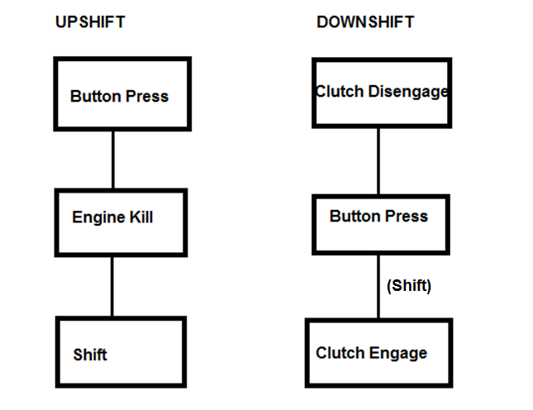
The following parts were needed for the setup-
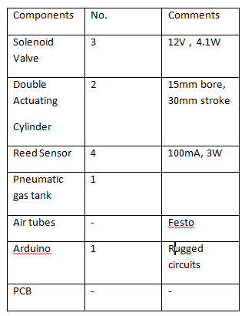

Arduino Gator Pin setup -

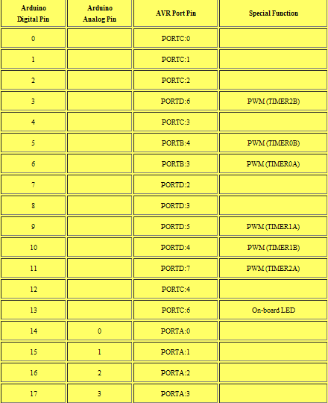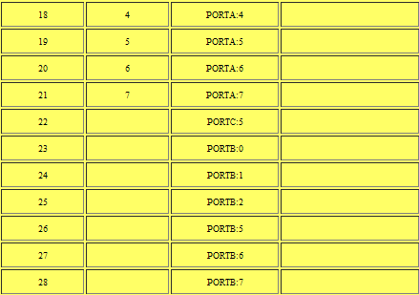

Please note that the interrupt pins are D2 andD3 (this was not given in the pin setup and had to be found out by trial and error).

Out of the required parts. Parts (1 – 5) were sourced by the last team.
The two primary objectives were -
- Design of a good quality ,reliable printed circuit board.
- Writing code to program the microcontroller to control the setup.

Design for manufacture-

Designing the PCB –
Various parameters taken into account for designing were –
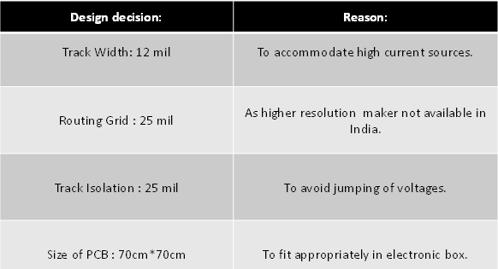

A rendered image of the board –

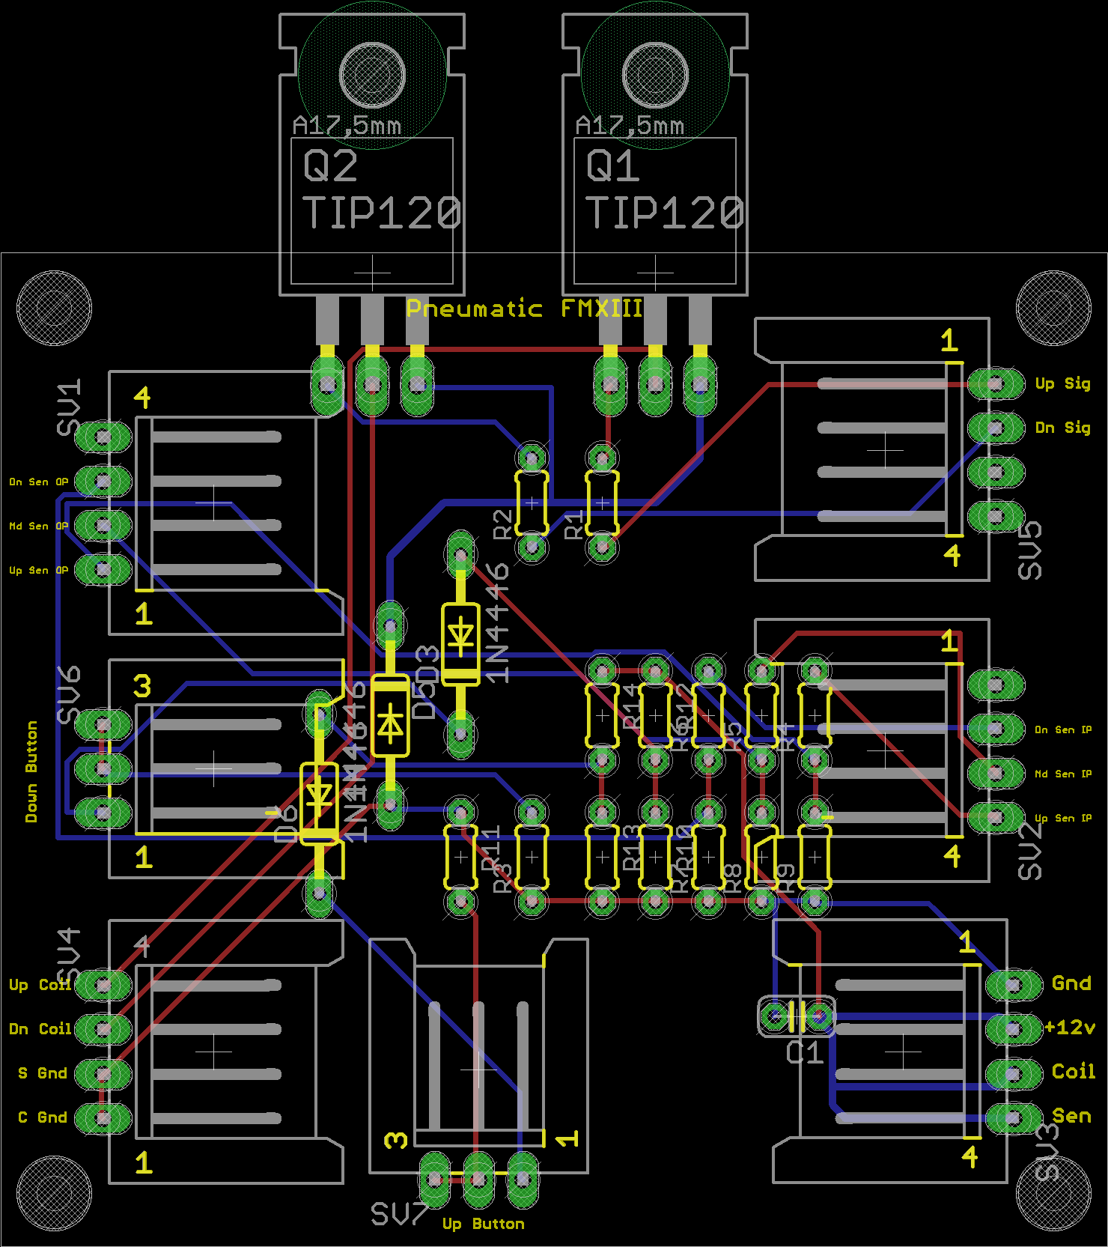

The parts used in the PCB are given below –
Assembly variant:
Part Value Library No. Remark
Resistor 1Kohm rcl 8 Voltage divider
Resistor 10Kohm rcl 3 Current Limiting
Capacitor 0.1uF rcl 1 Bypass
Transistor TIP 121 trans 3 Switching
Con-amp conn. 4 pin con 8 Connectors

Writing code for the microcontroller –
Code was written for the arduino microcontroller. However there was a problem in getting certain pins to respond properly. The code was modified and an exit controlled loop was used and was successful in running a basic pneumatic setup. Certain problems occurring were –
- Double shifting of gears – This problem should be solved by the use of interrupts in the code. Tests are ongoing.
- Half shifting from 1 to neutral – This problem should be solved placing the reed sensors appropriately.
- Slow gear shifts.
The problem with the double shifting should be solved with the use of interrupts in the code.
Both the codes are given at the end of the report.

Design for assembly –
The PCB was decided to be bolted to the board housing all the electronic components by M3 bolts (As this would also help in heat dissipation from the board). It was decide that the PCB would be placed between the ECU and the arduino on the right side of the ECU as shown in the picture –
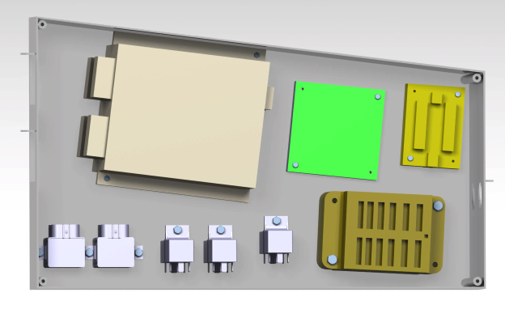
The wires from the sensors and the valves will be connected to the PCB by amp-mt connectors mounted on it.
The position of the solenoids on the new chassis has not been decided as yet.

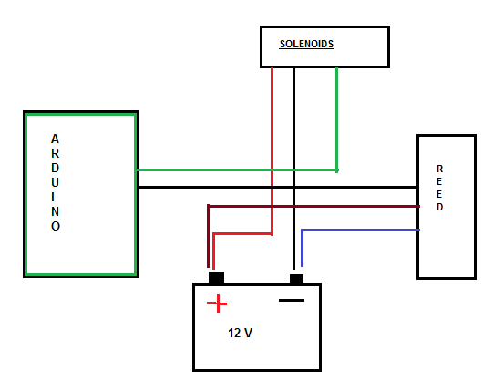
Schematic for the pneumatic setup
(keep in mind the color code in the schematic as the sensors are not color coded)

Pneumatic code without interrupt –
const int ledpin1=0;
const int ledpin2=1;
const int ledpin3=2;

const int buttonpin1=4;
const int buttonpin2=7;
const int solenoidpin1=8;
const int solenoidpin2=12;
int buttonstate1=0;
int buttonstate2=0;
int lastbuttonstate1= LOW;
int lastbuttonstate2= LOW;
long int lastdebouncetime1=0;
long int lastdebouncetime2=0;
long int debouncedelay=30;
int g=1;

void setup()
{
Serial.begin(9600);

pinMode(ledpin1, INPUT);
pinMode(ledpin2, INPUT);
pinMode(ledpin3, INPUT);
pinMode(buttonpin1, INPUT);
pinMode(buttonpin2, INPUT);
pinMode(solenoidpin1, OUTPUT);
pinMode(solenoidpin2, OUTPUT);

}
void loop()
{

digitalWrite(solenoidpin1,LOW);
digitalWrite(solenoidpin2,LOW);

if(digitalRead(buttonpin1)==HIGH )
{
int reading1= digitalRead(buttonpin1);
if(reading1!=lastbuttonstate1)
{
lastdebouncetime1=millis();
}
if((millis()-lastdebouncetime1)>debouncedelay)
{
buttonstate1=reading1;
}

lastbuttonstate1=reading1;
if(buttonstate1== HIGH && digitalRead(ledpin2)== HIGH && g>1)
{
Serial.println("Downshift");
do{

digitalWrite(solenoidpin1, HIGH);
} while(digitalRead(ledpin3)==LOW);
if(digitalRead(ledpin3==HIGH))
{
g--;
Serial.println(g);
}

}
delay(100);
buttonstate1==reading1;
}

if(digitalRead(buttonpin2)== HIGH )
{
int reading2=digitalRead(buttonpin2);
if(reading2!= lastbuttonstate2)
{
lastdebouncetime1=millis();
}
if((millis()-lastdebouncetime1)>debouncedelay)
{
buttonstate2= reading2;
}
lastbuttonstate2=reading2;

if( buttonstate2 == HIGH && digitalRead(ledpin2) == HIGH && g<=6 )
{
Serial.println("UPSHIFT");
do{

digitalWrite(solenoidpin2, HIGH);
} while(digitalRead(ledpin1)==LOW);
if(digitalRead(ledpin1==HIGH))
{
g--;
Serial.println(g);
}

}
delay(100);
buttonstate1==reading2;
}
}

Pneumatic code with interrupt –
int upshiftbutton=A3;
int downshiftbutton=A4;
int upsensor=A0;
int middlesensor=A2;
int downsensor=A1;
int upshiftcoil=10;
int downshiftcoil=8;
int sensorvalueup;
int sensorvaluemiddle;
int sensorvaluedown;
int ipin2 = LOW;
int ipin1 = LOW;
long debouncedelay = 50;
int lastbuttonstate2 = LOW;
int lastbuttonstate1 = LOW;
long lastdebouncetime2 = 0;
long lastdebouncetime1 = 0;
int buttonstate1;
int buttonstate2;
int reading1;
int reading2;

void setup ()
{
pinMode(downshiftbutton,INPUT);
pinMode(upshiftbutton,INPUT);
pinMode(middlesensor,INPUT);
pinMode(downsensor,INPUT);
pinMode(upshiftcoil,OUTPUT);
pinMode(downshiftcoil,OUTPUT);
attachInterrupt(0,DOWNSHIFT,RISING);
attachInterrupt(1,UPSHIFT,RISING);
}

void loop ()
{
if( digitalRead (upshiftbutton) != lastbuttonstate1)
{
lastdebouncetime1 = millis();
}
if ((millis() - lastdebouncetime1) > debouncedelay)
{
buttonstate1 = reading1;
}
digitalWrite(upshiftbutton, buttonstate1);
if (digitalRead(upshiftbutton) == HIGH && digitalRead(middlesensor) == HIGH)
{
digitalWrite(ipin1,HIGH);
}
lastbuttonstate1 = reading1;
if(digitalRead (downshiftbutton) != lastbuttonstate2)
{
lastdebouncetime2 = millis();
}

if ((millis() - lastdebouncetime2) > debouncedelay)
{
buttonstate2 = reading2;
}
digitalWrite(downshiftbutton, buttonstate2);
if (digitalRead(downshiftbutton) == HIGH && digitalRead(middlesensor) == HIGH)
{
digitalWrite(ipin2,HIGH);
}
lastbuttonstate2 = reading2;
}
void DOWNSHIFT ()
{
do{
digitalWrite(upshiftcoil,HIGH);
}
while(digitalRead(upsensor) != HIGH);
}

void UPSHIFT ()
{
Do
{
digitalWrite(upshiftcoil,HIGH);
}
while(digitalRead(downsensor)!= HIGH);
}

- Pranay Singh (Electronics) FMXIII

